727720EUEC507

PRADEEPKUMAR V

**ASSIGNMENT 4-BUZZER FOR ULTRASONIC SENSOR**

**PROGRAM:**

int t=2;

int e=3;

void setup()

{

Serial.begin(9600); pinMode(t,OUTPUT); pinMode(e,INPUT); pinMode(12,OUTPUT);

}

void loop()

{

//ultrasonic sensor digitalWrite(t,LOW); digitalWrite(t,HIGH); delayMicroseconds(10); digitalWrite(t,LOW);

float dur=pulseIn(e,HIGH); float dis=(dur*0.0343)/2; Serial.print("Distance is: "); Serial.println(dis);

//LED ON

if(dis>=100)

{

digitalWrite(8,HIGH); digitalWrite(7,HIGH);

}

//Buzzer For ultrasonic Sensor if(dis>=100)

{

for(int i=0; i<=30000; i=i+10)

{

tone(12,i); delay(1000); noTone(12); delay(1000);

}

}

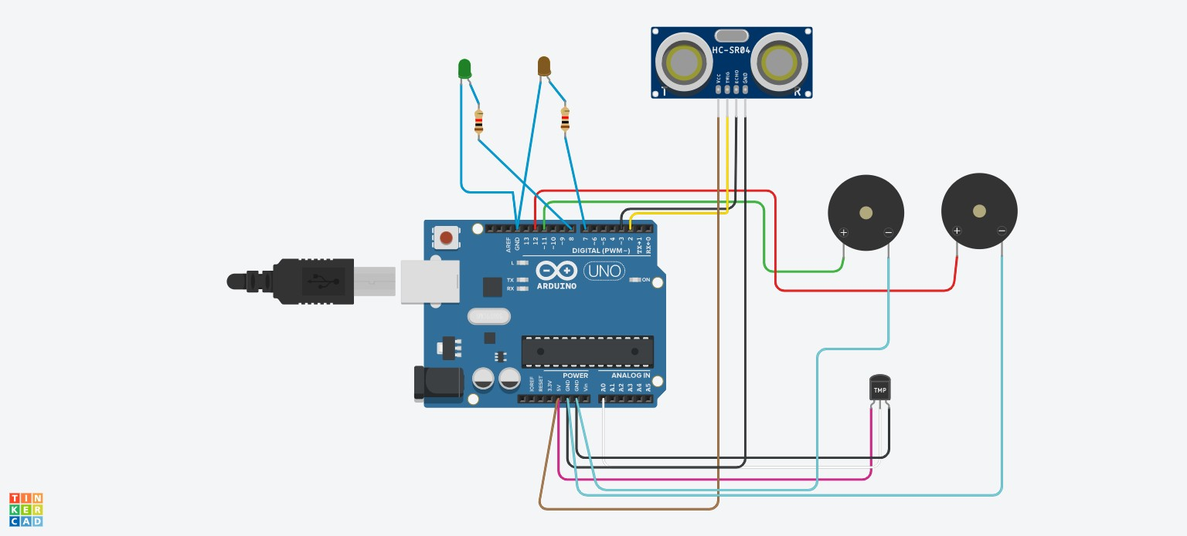**OUTPUT**